**Assignment –1**

**A) SALESPEOPLE**

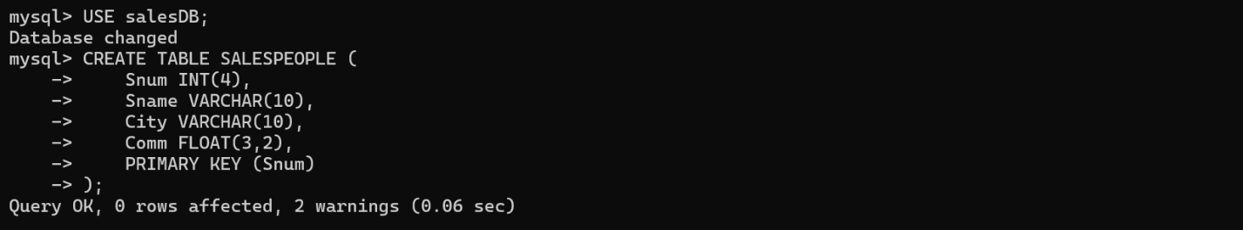

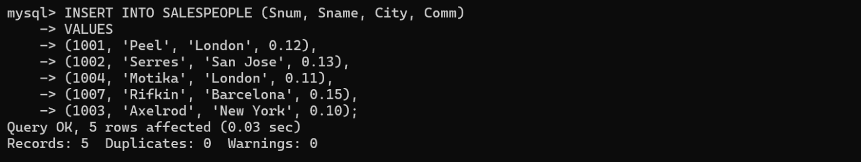

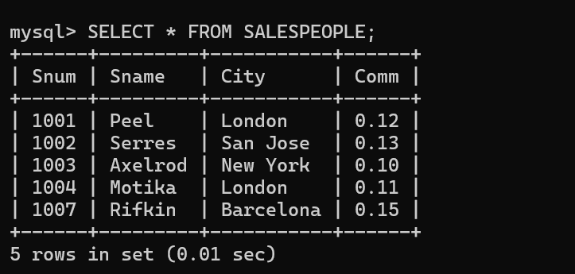

B) CUSTOMERS

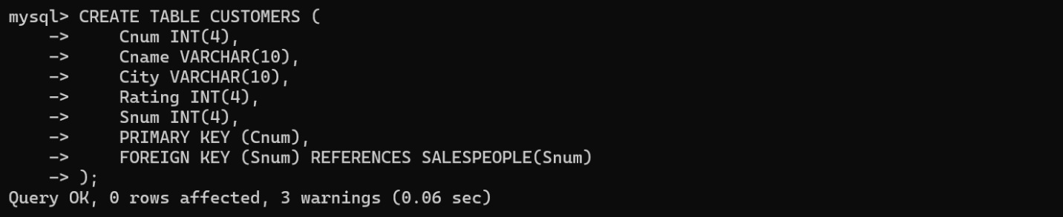

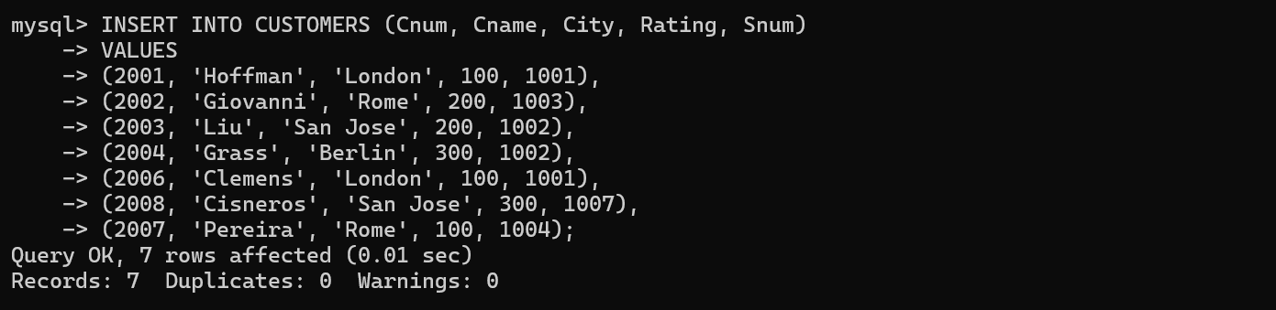

C .ORDER:

